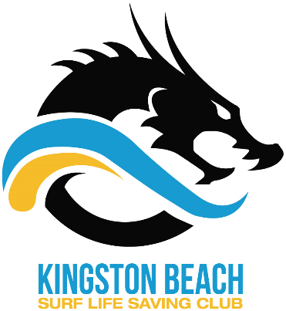

Club Clothing Price list

Boys Bathers | $35
Men’s Bathers | $40
Boys Jammers | $40
Men’s Jammers | $45
Club Hoodie | $60
Club Hoodie (old style) | $30
Club Polo | $35
Training Singlet | $30
Club Shirt | $35
Club Cap | $15
White Shirt | $35
Pink Vest | $20
Track Pants (Adult) | $40
Track Pants (Kids)  Seahorse Cap | $35  $10
Long sleeve Rash vest | $15

