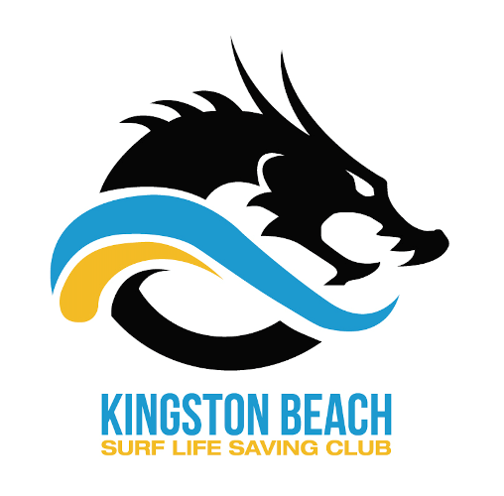
Kingston Beach SLSC Membership Payments

EXISTING MEMBERS

Now that the 2017/18 season is just around the corner, it’s time to update membership details and to pay annual subscriptions. Membership fees have increased slightly this year however Early Bird fees remain the same as last season and the deadline has been extended, so grab a bargain.
Please follow the guidelines below. If you have difficulty contact the SLSA Help Desk on 1300 724 006 (email ithelp@slsa.asn.au) or email Michelle at kingstonbeachslsc@gmail.com.

1. Go to portal.sls.com.au
2. Enter your username and password to log in to your account
3. Select the tab Lifesaving Online, then click Online Payments
4. Click Membership Renewal and you should be directed to a page to pay your membership and update any personal details.

** To create and pay for a family group select the tab Life Saving Online – My family and search and select your family members.

MEMBERSHIP FEES
Category | Early bird  Until 26/11/2017 | Fees
Family | 270 | 300
Active  (patrolling member >16) | 130 | 150
Cadet  (13-15) | 120 | 140
Junior  (U8-U12) | 100 | 120
Seahorse  (5&6 year old) | 85 | 95
Associate  (non-active/social) | 65 | 80

Looking forward to seeing you on the beach again for another great season.

