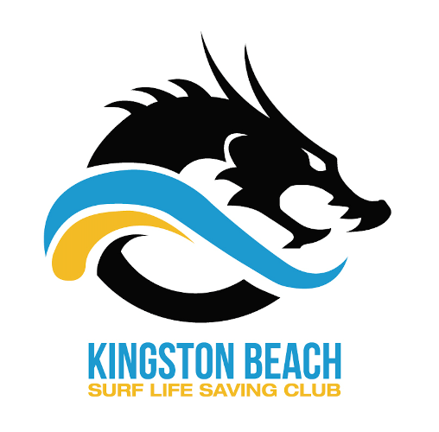
Kingston Beach SLSC Membership Payments

NEW MEMBERS
(Registration is completed on-line through Surf Life Saving Australia)
- Go to join.sls.com.au

Select Entity: Surf Life Saving Club
Select State: Surf Life Saving Tasmania
Club/Organisation: Kingston Beach SLSC

Add individual details (please note the form is quite detailed and not all information is required).
Once you have created your individual account with SLSA you must then go on to create a Portal account.

- Go to portal.sls.com.au

Create a new Portal account (separate account for each family member)
Enter details – you will receive an SMS or email to continue
Choose a user name and password and activate your account
To pay your membership you must be logged in to your Portal Account, choose the tab Lifesaving Online, Online payments, Membership renewal
To create a family account and pay as a family, create a portal account for all family members individually, then choose “my family” and create a family group.

Category | Early Bird  (before 26/11/2017) | Fees
Family | 270 | 320
Active (patrolling member >16) | 130 | 160
Cadet (13-15) | 120 | 150
Nipper (U8-U12) | 100 | 130
Seahorse (5-7 year olds) | 85 | 95
Associate  (non-active/social) | 65 | 80

If you have difficulty contact the SLSA Help Desk on
1300 724 006 (email ithelp@slsa.asn.au) or email Michelle at kingstonbeachslsc@gmail.com.

